How to use the Dental Fallow Time Calculator

STEP 1 - REGISTER
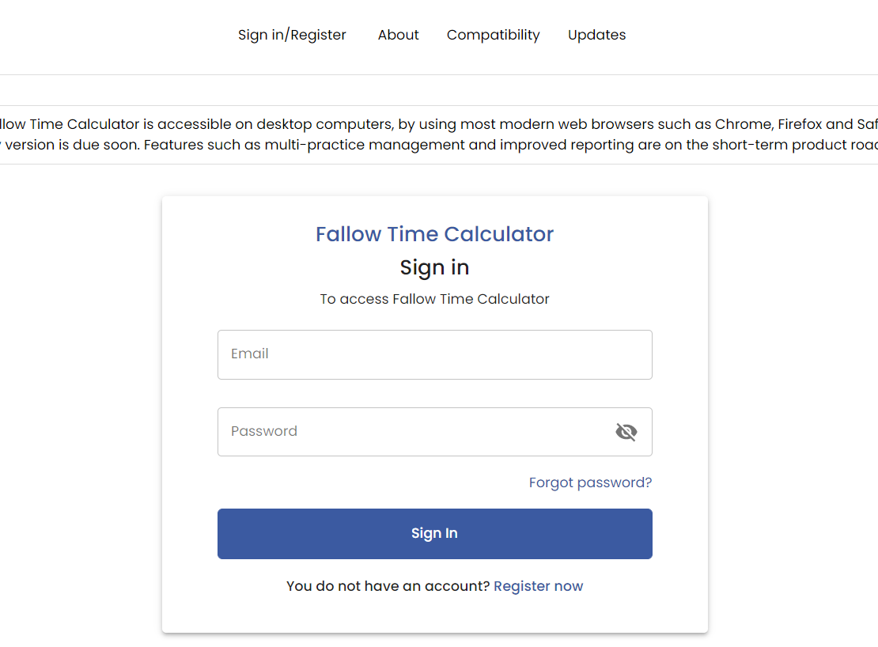

Press the Register button and follow the steps
STEP 2 – Fill out the Full name, Phone number and email. You will receive shortly and email to set up your password.
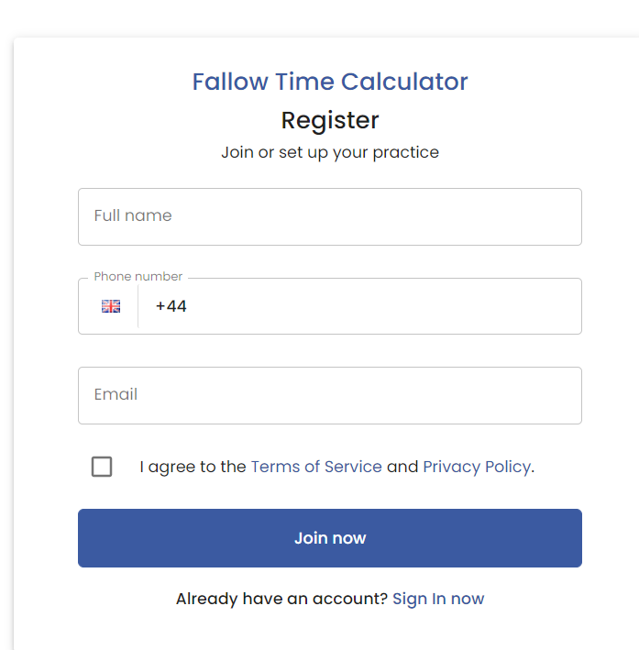
STEP 3 – You will receive shortly and email to set up your password.

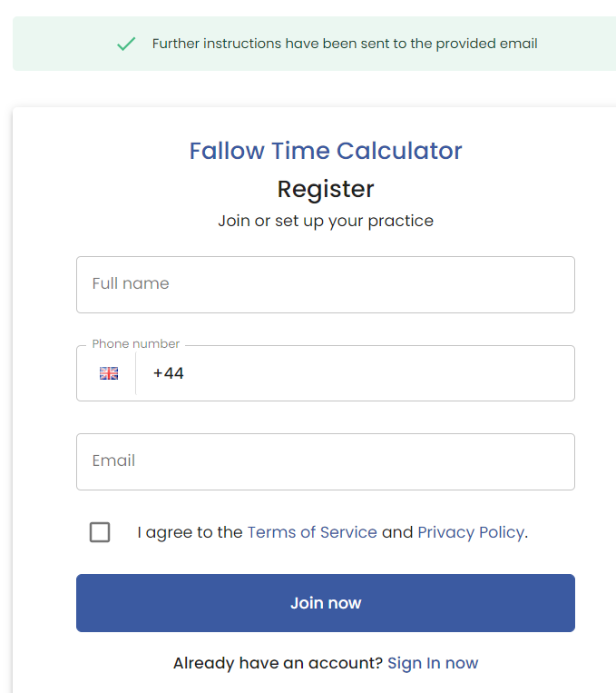

- Go into the email and set up your password
- Sign In with the registered email and password.

STEP 4 – Create a ROOM


Press Fallow Time Calculator and Create Room
STEP 5 -ADD ROOM
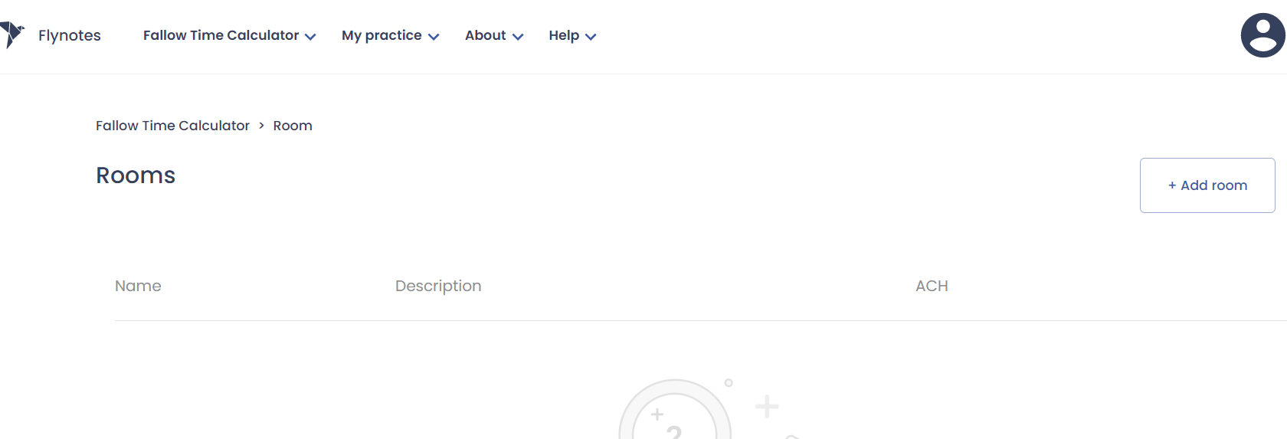
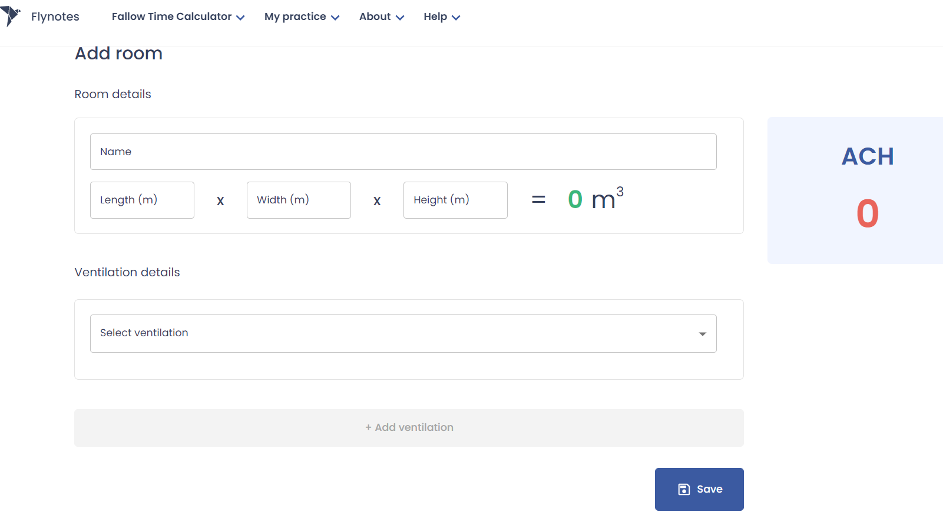

Add all the missing information and click on SAVE button. You can get these measurements from your Building Plan or you can download the MAGIC PLAN application.
STEP 6 -CREATE TREATMENT
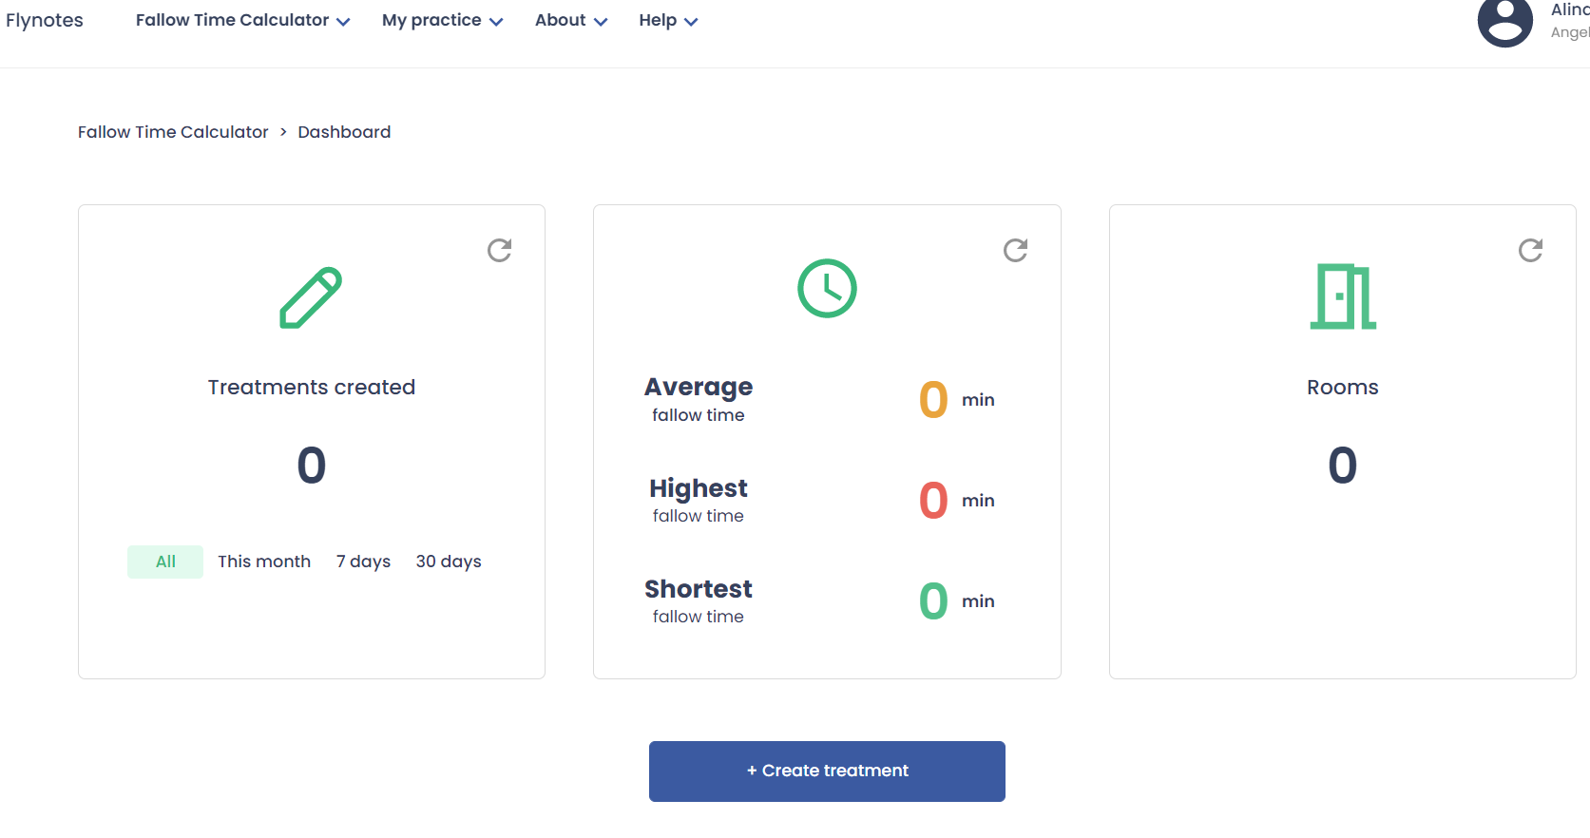
Press CREATE TREATMENT button
STEP 7 – Add all the information required such as: Patient name, Date of birth, Full address, etc.
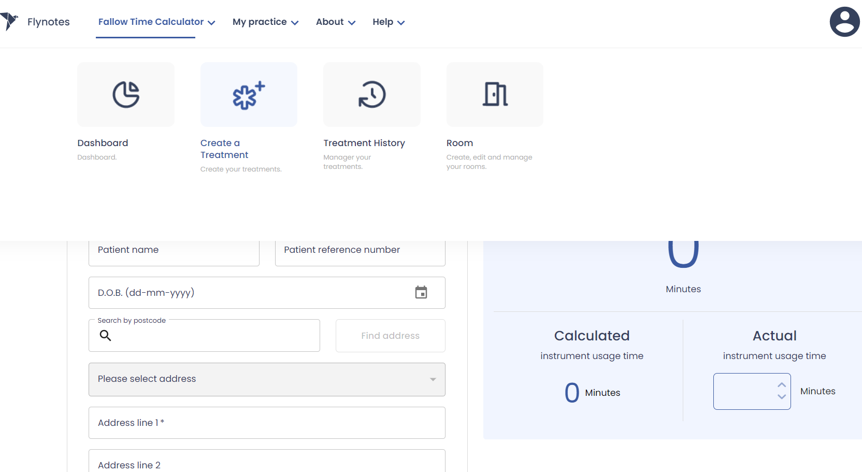
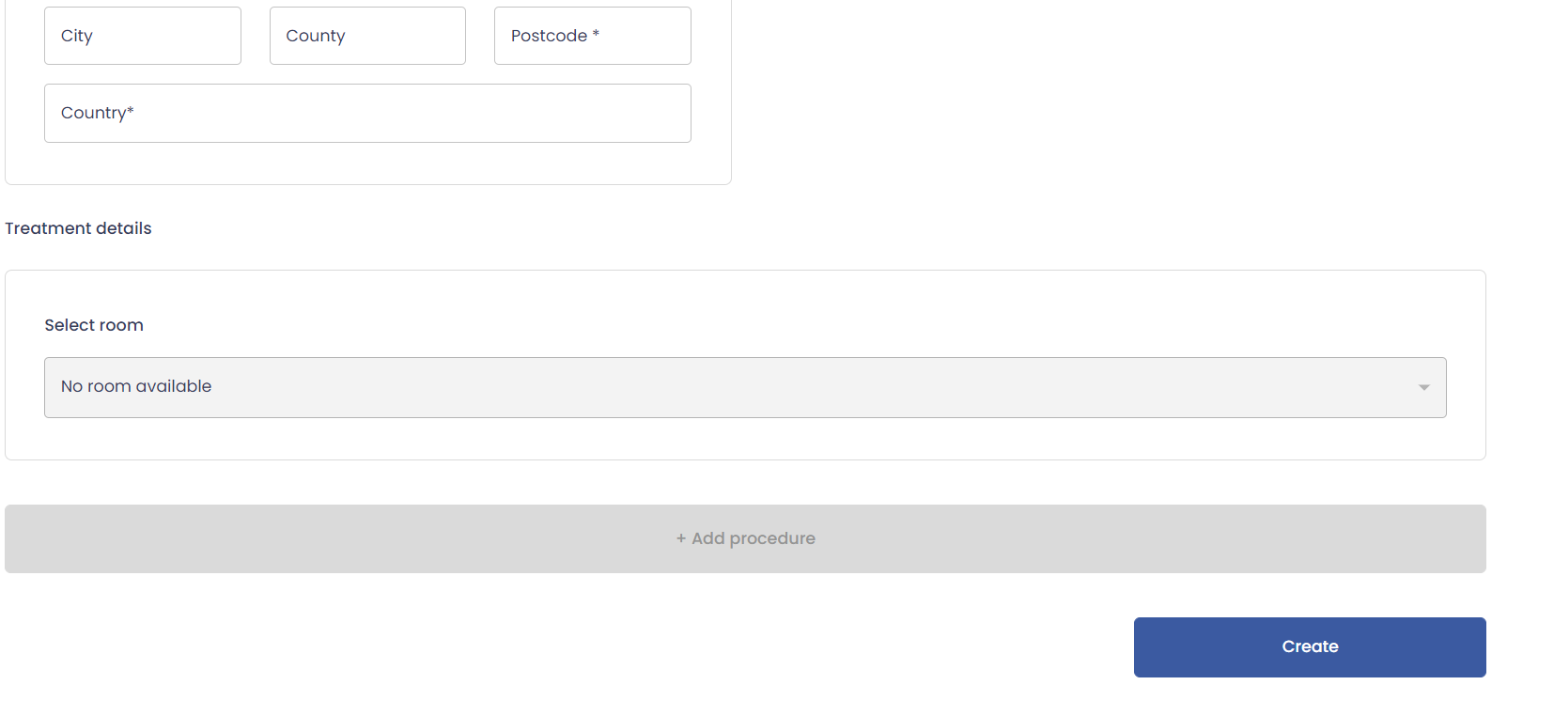
Click on ADD PROCEDURE button
Select the room available
STEP 8- Select Procedure: AMALGAM RESTAURATION for example.
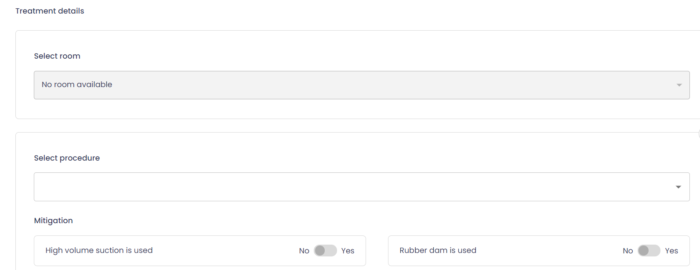
Click YES
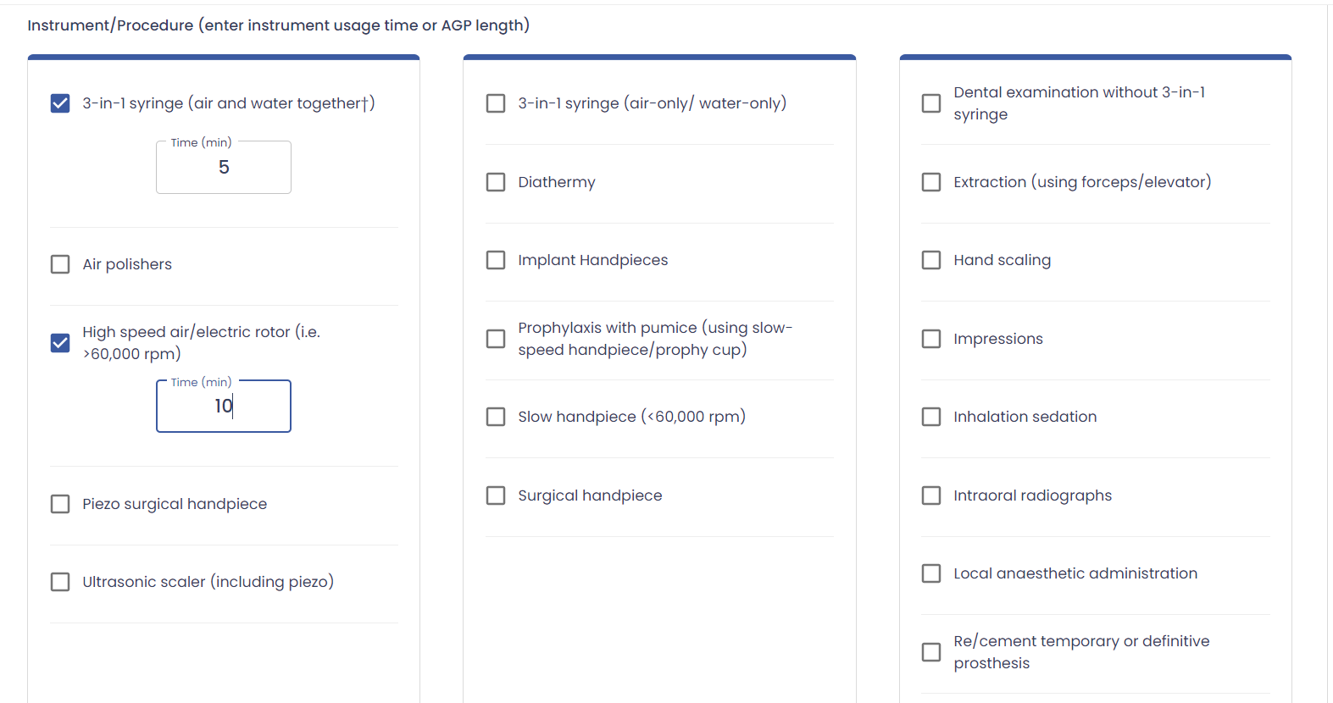

For Amalgam procedure we use 3 in 1 syringe, tick the box also add the time of how long the clinician use it for? Ex 5 minute

High speed hand piece used for 10 min, for example

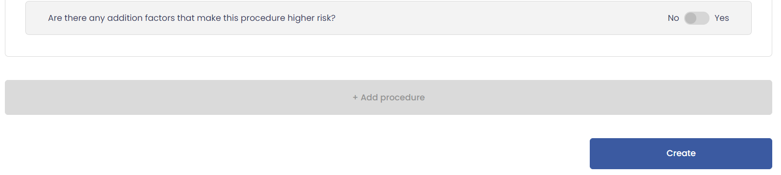

If you need to add additional information, click YES, if not click NO
Click CREATE button

STEP 9- The calculator will generate the Fallow time for this procedure based on the information entered.
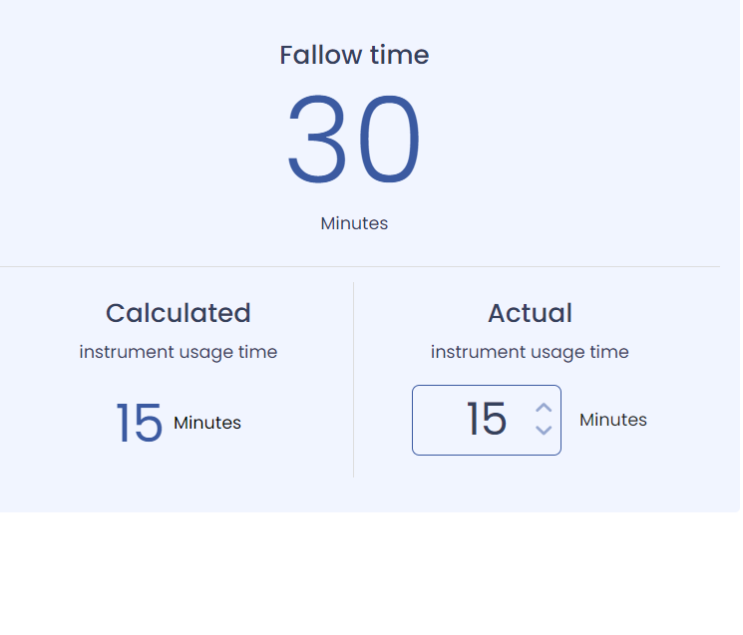

STEP 10- Save the procedure
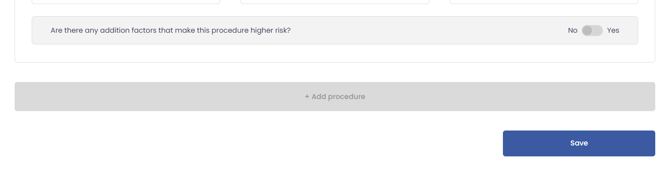

If you want to save this procedure, press the SAVE button.



